**HTML | <th> scope Attribute**

Last Updated : 01 Aug, 2022

The **HTML <th> scope Attribute** is used to *specify the header cell is used for header row, column, colgroup or rowgroup*. This attribute does not display any visual effect on the browser but it is used for screen readers.

**Syntax:**

<th scope="col | row | colgroup | rowgroup">

**Attribute Values:**

* **col:** It specifies that the header cell is used for column.
* **row:** It specifies that the header cell is used for row.
* **colgroup:** It specifies that the header cell is used for group of column.
* **rowgroup:** It specifies that the header cell is used for group of row.

**Example:**

**html**

|  |
| --- |
| <!DOCTYPE html>  <html>    <head>      <title>          HTML th scope Attribute      </title>  </head>    <body>      <h1>GeeksforGeeks</h1>        <h2>HTML th scope Attribute</h2>        <table border="1" width="500">          <tr>              <th scope="col">NAME</th>              <th scope="col">AGE</th>              <th scope="col">BRANCH</th>          </tr>            <tr>              <td>BITTU</td>              <td>22</td>              <td>CSE</td>          </tr>            <tr>              <td>RAKESH</td>              <td>25</td>              <td>EC</td>          </tr>      </table>  </body>    </html> |

**Output:**

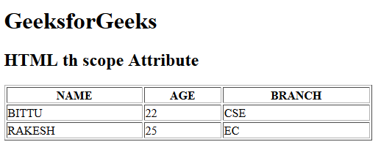

**Supported Browsers:** The browser supported by **HTML <th> scope attribute** are listed below:

* Google Chrome 1
* Edge 12
* Internet Explorer
* Firefox 1
* Safari
* Opera

Dive deep into the world of JavaScript with our [JavaScript Full Course Online](https://www.geeksforgeeks.org/courses/javascript?utm_campaign=three_90_345_abt&utm_medium=gfgcontent_abt&utm_source=geeksforgeeks), offering everything from the basics to advanced techniques. Learn how to build interactive websites, optimize your code, and earn a certification to showcase your skills.  
  
Take the **Three 90 Challenge**! Complete **90% of the course** in **90 days**, and **earn a 90% refund**. Push your limits and stay motivated as you work towards mastering JavaScript. Join now and get started on your **JavaScript learning journey!**

Comment

More info

[Advertise with us](https://www.geeksforgeeks.org/about/contact-us/?listicles)

[**Next Article**](https://www.geeksforgeeks.org/html-td-scope-attribute/?ref=next_article)

[HTML | <td> scope Attribute](https://www.geeksforgeeks.org/html-td-scope-attribute/?ref=next_article)

**Similar Reads**